

MOM & ME

INFS 496 - System Analysis & Design  
Group No: 4

Members: Ed Graft, Nadia Siddiqui, Neha Goel, Sarchina Kumari



Contents

**a.** **Logical Database Design Explanation** 3

**b.** **Logical Database Design** 3

**c.** **Physical Database Design Explanation** 4

**d.** **Normalized Physical Database Design** 4

**i.** **Sample Tables for Entities** 4

**e.** **File Organization** 4

**f.** **Controls** 5

**g.** **Forms** 5

**h.** **Reports** 14

**i.** **Design Specification** 14

**i.** **Narrative Overview** 14

**1.** **Interface/Dialogue Name:** 14

**2.** **User Characteristics:** 14

**3.** **Task Characteristics:** 15

**4.** **System Characteristics:** 15

**5.** **Environment:** 15

**ii.** **Interface and Dialogue Designs** 15

**1.** **Forms/Reports Design:** 15

**2.** **Dialogue Design:** 15

**iii.** **Testing and Usability Assessment** 16

**1.** **Testing Objective:** 16

**2.** **Testing Procedures:** 16

**iv.** **Dialogue Diagram** 16

**1.** **Diagram** 16

**v.** **Distributed System Design** 17

**1.** **Description of Site:** 17

# **Logical Database Design Explanation**

**Client:** It is the basis table having the details of a Mother (Client). The primary Key is the Client_ID. Doctor_ID is the foreign key from Doctors Table indicating the Doctor for the particular Client. Other attributes are the Client’s Personal Information. The Client table is connected with Doctor to read her Doctor’s information. Administrator table is connected so that Client can read the Baby Names and give her feedback. Client can access the Nutrition Plan and medication provided to her from the Nutrition Plan Table. She can plan for her Baby Shower and enter details so Baby Shower table is connected with Client.

**Doctor:** The primary Key is the Doctor_ID. This identifier will connect the Doctor with the Administration, Client and the Nutrition Plan. Other attributes of Doctor Table is his personal information. Doctor can enter Nutrition plan, medication for his client weekly in the Nutrition Plan table.

**Administrator:** Application_FormNo is the Primary Key of the table which is the Form No when the Client first comes to the hospital. Client_ID and Doctor_ID are the foreign keys for the table to connect with the Doctor and the Client. Feedback would to be provided by Doctor and Client. Baby Names suggestions can be viewed by Client. Admin has the access to the whole application and database.

**Login:**  Username and Password both the attributes will be unique, Username is the Primary Key. Admin, Client and Doctor all will be having their own login username and password to work in the application. Although as their access levels will be different so there is an Access attribute which will decide their access restrictions.

**Forum :**Client_ID and Doctor_ID are the foreign keys of the table. Both doctor and the client can read and write the feedback. A separate attribute for baby names suggestions to the mother.

**Nutrition Plan:** Doctor_ID and Client_ID together form the Composite Primary Key for the table. The Doctor can add Nutrition Plan and Medication on weekly basis for his particular client. Client can read the Plan provide by the doctor.

**Baby Shower:** Event_ID is the primary Key for the table. Client can create a Baby shower event and can add the Event Name, Organizer, Date and send invitees.

# **Logical Database Design**

**Client** :Client_ID, Doctor_ID, C_Name, C_Address, C_PhoneNo, C_Email, C_Family,

**Doctor** :Doctor_ID, D_Name, D_Address, D_PhoneNo, D_Specialization, D_Email,

**Administrator**: Application_FormNo, Doctor_ID, Client_ID,

**Login**: Username, Password, Access

**Forum**: Doctor_ID, Client_ID, Feedback, BabyNames

**Nutrition Plan** :Doctor_ID, Client_ID, Week, Nutrition Plan, Medication

**Baby Shower** :Event_ID, Event_Name, Event_Organizer, Event_date, Invites

# **Physical Database Design Explanation**

Normalized

The normalized database was designed so information that is needed to be accessed can be found in same place with no redundancy.

* **Client:** The entity shows the Client_ID with the corresponding client’s personal information and her Doctor Id.
* **Doctor**: The entity shows the Doctor_ID with the corresponding Doctor’s Information.
* **Administrator**: Each Mother has her Form no of the hospital stored as Application_FormNo accessing all the details of her doctor and other services.
* **Login**: A separate entity for users login information is created so that each user can be given his/her Username and Password according to their Access levels of the application.
* **Forum**: A general Forum entity is created to store the feedback/comments or issues from the doctor and the Mother. Baby Names suggestions are also stored.
* **Nutrition Plan**: This contains the ids of both the doctor and the client as the primary key as Doctor will be providing different Nutrition plans and Medication for different week for respective clients.
* **Baby Shower**: This stores the Baby Shower Event details which the Mother adds while creating her baby shower event.

# **Normalized Physical Database Design**

## **Sample Tables for Entities**

|  |  |  |  |  |  |  |
| --- | --- | --- | --- | --- | --- | --- |
| ***CLIENT Table*** | | | | | | |
| **Client_ID** | **Doctor_ID** | **C_Name** | **C_Address** | **C_PhoneNo** | **C_Email** | **C_Family** |
| C_01 | D_01 | Stone, Mary | 1209 Arthur Ave, Chicago | 9804235677 | [mary_stone@gmail.com](mailto:mary_stone@gmail.com) | Father - Sam |
| C_02 | D_02 | Holleran, Nikita | 4249 N Bloom Ave, AL | 9837064124 | [niki_holl@yahoo.com](mailto:niki_holl@yahoo.com) | Husband - Karan |
| C_03 | D_03 | Fernandes, Mona | 182 W Lake Street, Chicago | 3124432629 | [mona_F@gmail.com](mailto:mona_F@gmail.com) | Mother - Marya |
| C_04 | D_04 | Qasim, Aya | 1229 W Fluornoy Street, Chicago | 6667345590 | [Aya_Qasim@yahoo.com](mailto:Aya_Qasim@yahoo.com) | Husband - Sameer |
|  |  |  |  |  |  |  |
|  |  |  |  |  |  |  |
|  |  |  |  |  |  |  |

|  |  |  |  |  |  |
| --- | --- | --- | --- | --- | --- |
| ***Doctor Table*** | | | | | |
| **Doctor_ID** | **D_Name** | **D_Address** | **D_PhoneNo** | **D_Email** | **D_Specialization** |
| D_01 | Bianca Joseph | 1229 W University Street, Chicago | 4435567890 | [Bianca@gmail.com](mailto:Bianca@gmail.com) | Obstetrics & Gynaec |
| D_02 | Daniel Webber | 176 W Laker Street, AZ | 1238971654 | [Web@gmail.com](mailto:Web@gmail.com) | Family Planning |
| D_03 | Chelsea David | 4249 N Michigan Ave, Chicago | 1242161298 | [Chelsea@gmail.com](mailto:Chelsea@gmail.com) | Laprospic Surgery |
| D_04 | Leroy Gibbs | 1209 Drake Ave, MI | 1657654343 | [Gibbs@gmail.com](mailto:Gibbs@gmail.com) | Obstetrics & Gynaec |
|  |  |  |  |  |  |
|  |  |  |  |  |  |

|  |  |  |
| --- | --- | --- |
| ***Administration Table*** | | |
| **App_FormNo** | **Doctor_ID** | **Client_ID** |
| F0141 | D_01 | C_01 |
| F0142 | D_02 | C_02 |
| F0143 | D_03 | C_03 |
| F0144 | D_04 | C_04 |
|  |  |  |
|  |  |  |

|  |  |  |
| --- | --- | --- |
| ***Login*** | | |
| **Username** | **Password** | **Access** |
| admin1234 | admin1223445 | Admin |
| drgibbs | 1234qwerty | Doctor |
| mary1234 | mary0987 | Client |
| mona000 | 999888 | Client |
|  |  |  |
|  |  |  |

|  |  |  |  |
| --- | --- | --- | --- |
| ***Forum*** | | | |
| **Doctor_ID** | **Client_ID** | **Feedback** | **Baby Names** |
| D_01 | C_01 | I am very Happy with the doctor's consultation | John |
| D_01 | C_02 | Through Mom N Me I am very comfortable | Sam |
| D_03 | C_03 | Good Medication | Tony |
| D_04 | C_04 | Doctor can you please change my medication | Mary |
|  |  |  |  |
|  |  |  |  |

|  |  |  |  |  |
| --- | --- | --- | --- | --- |
| ***Nutrition Plan*** | | | | |
| **Doctor_ID** | **Client_ID** | **Week** | **Nutrition Plan** | **Medication** |
| D_01 | C_01 | 1 | Vegetables – greens, Milk, Juices | Calcium, multivitamins |
| D_02 | C_02 | 6 | No pineapple | Baby health meds |
| D_02 | C_03 | 8 | No fatty foods like cheese | Calcium, vitamins |
| D_03 | C_04 | 12 | No pineapple, smelly food | Multivitamins |
|  |  |  |  |  |
|  |  |  |  |  |

|  |  |  |  |  |
| --- | --- | --- | --- | --- |
| ***Baby Shower*** | | | | |
| **Event_ID** | **Event_Name** | **Event_organizer** | **Event_Date** | **Invites** |
|  |  |  |  |  |
|  |  |  |  |  |
|  |  |  |  |  |
|  |  |  |  |  |
|  |  |  |  |  |

# **File Organization**

The files will be stored using sequential organization. The files will be organized based on the value of the designated primary key. Example below for XXXX Table

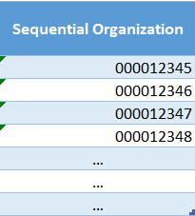

# 

# **Controls**

In order to maintain application operation several controls have been incorporated to keep the data integrity and avoid system failure.

* All data fields have designated data types with character limits
* Referential integrity
* Data is secured from outside member access
* Data is backed up nightly and physically stored on secured servers with limited physical access
* Store each system data request for backup, as well as security reference if needed
* File encryption

# **Forms**

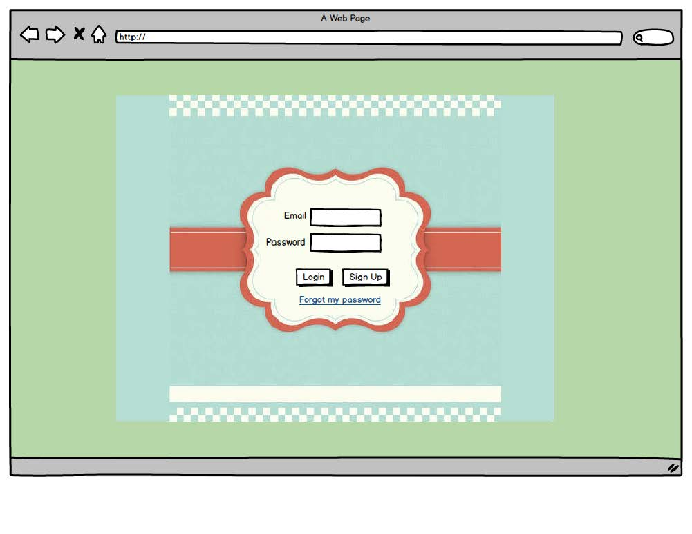

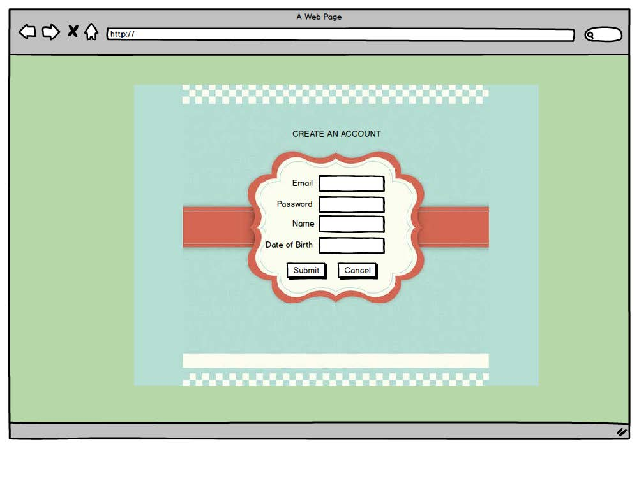

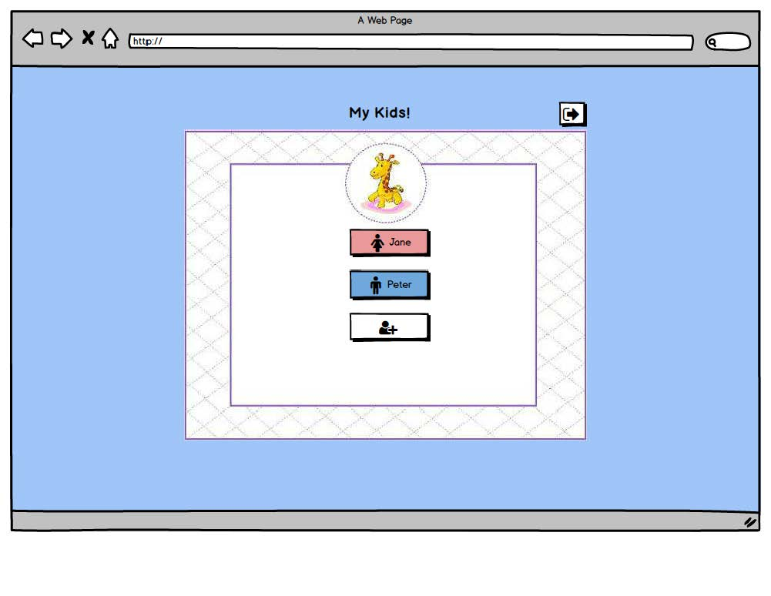

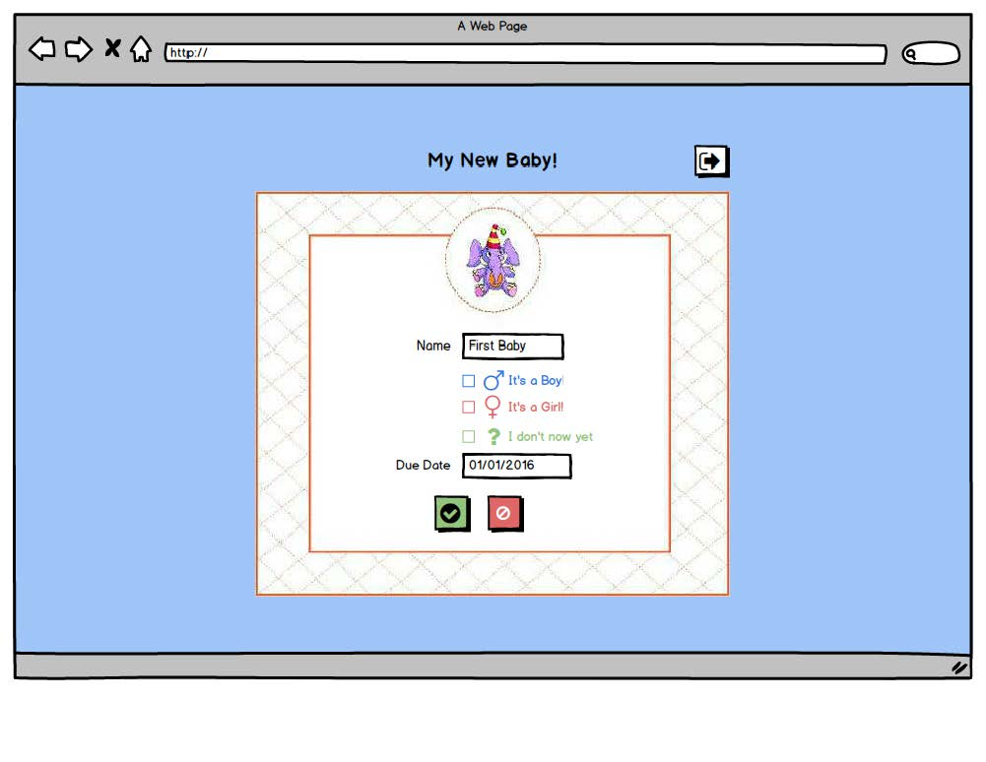

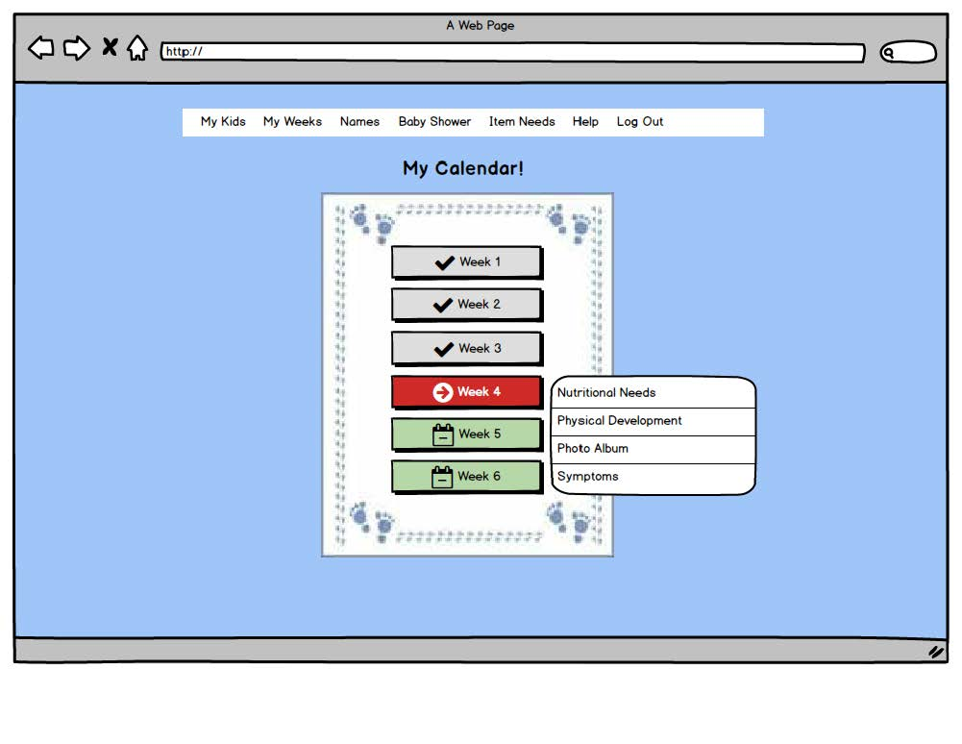

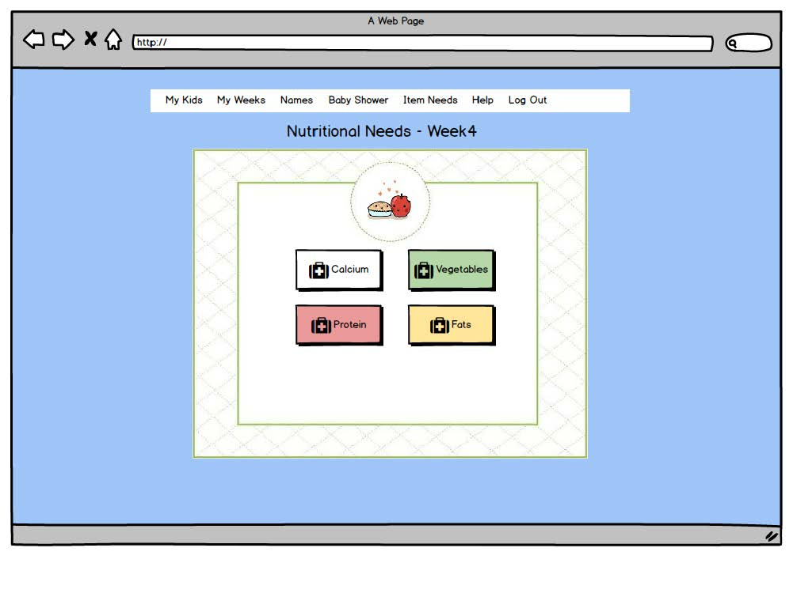

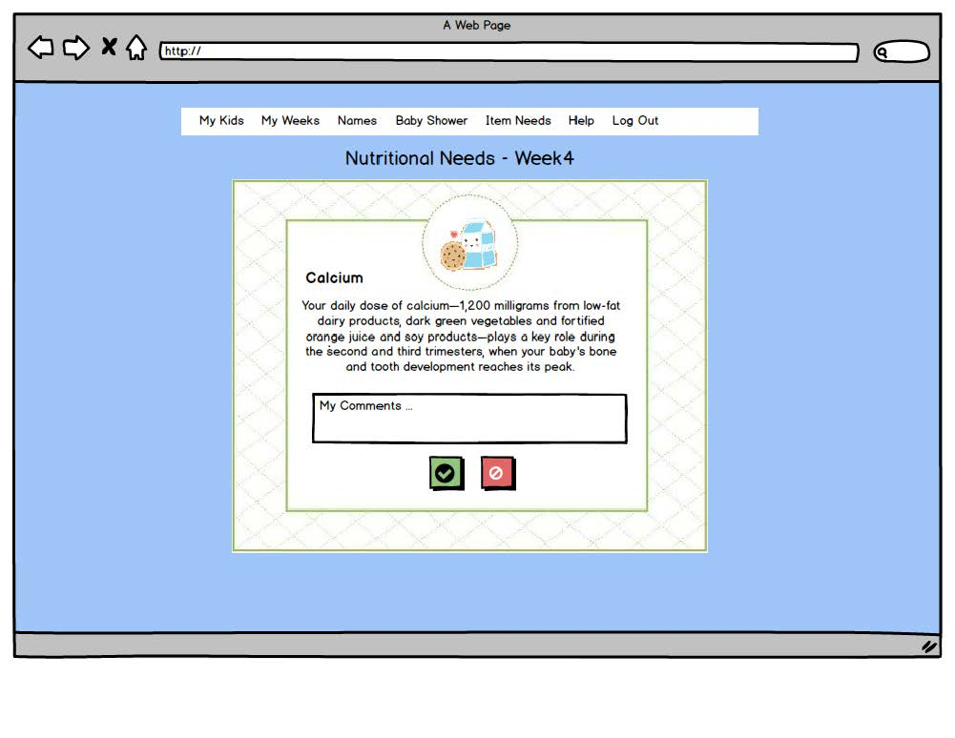

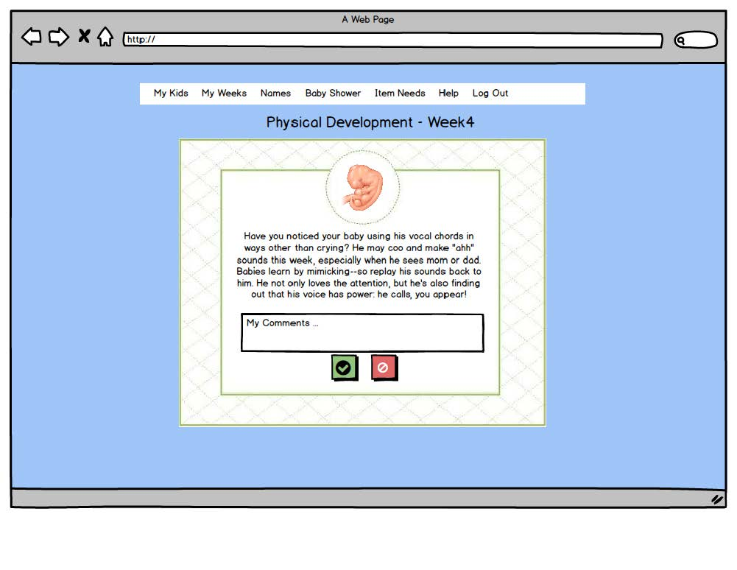

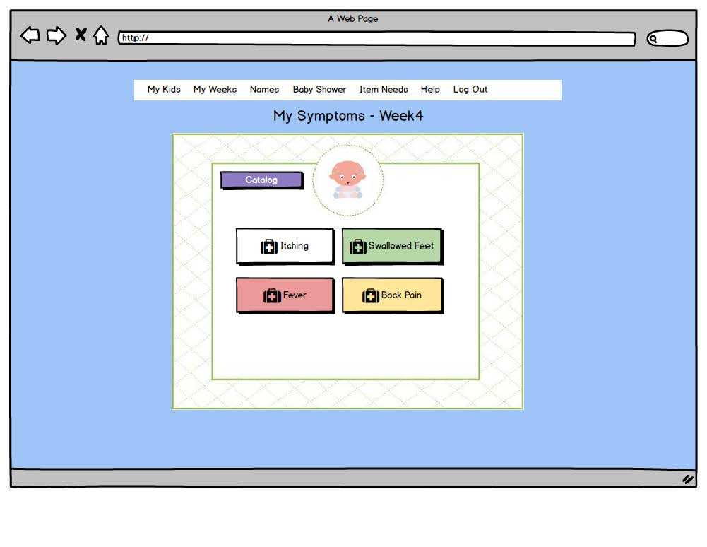

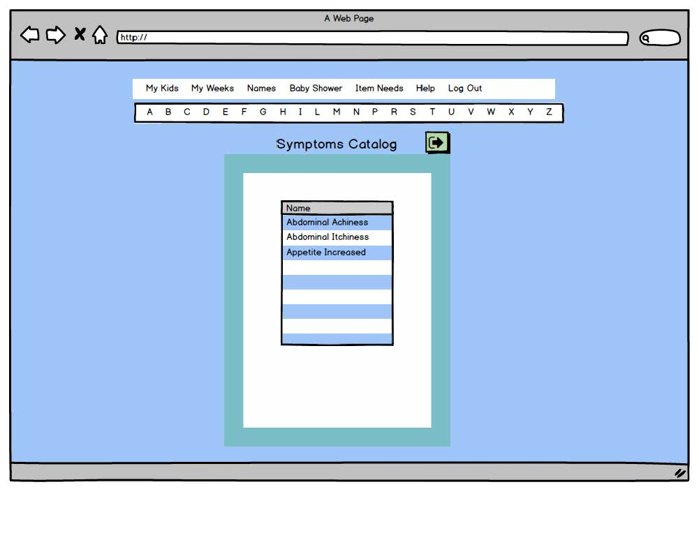

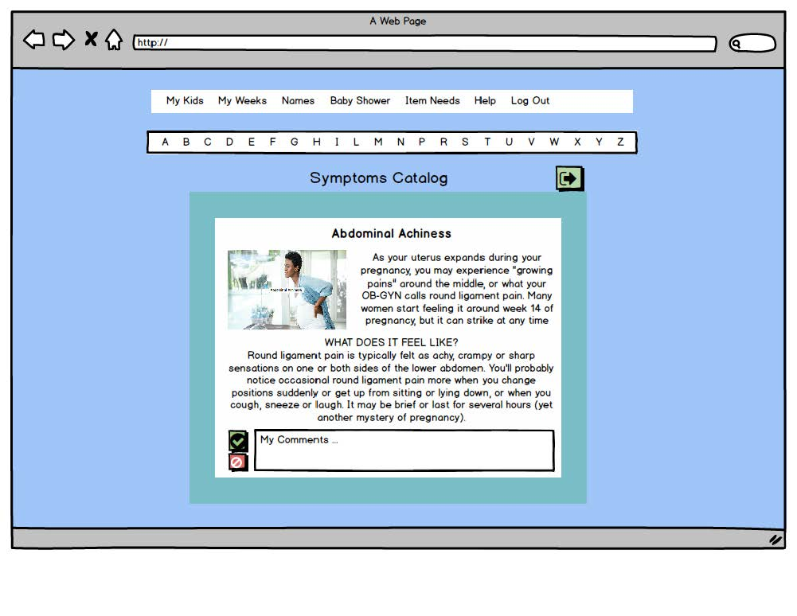

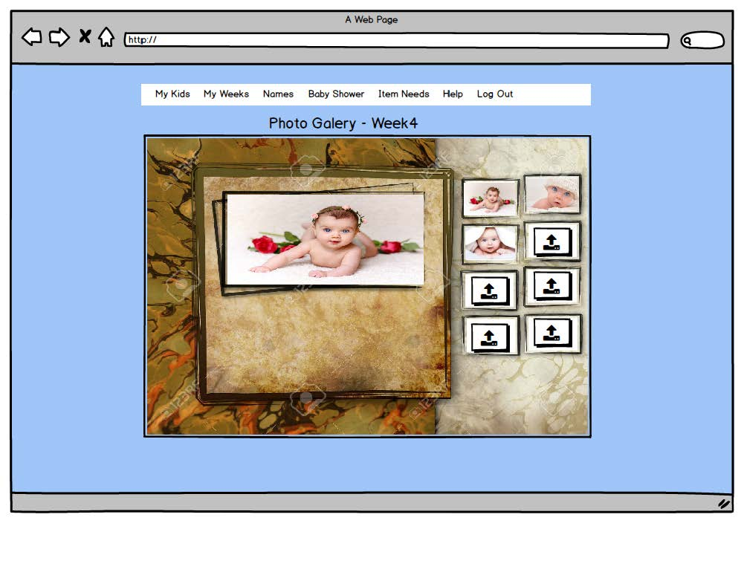

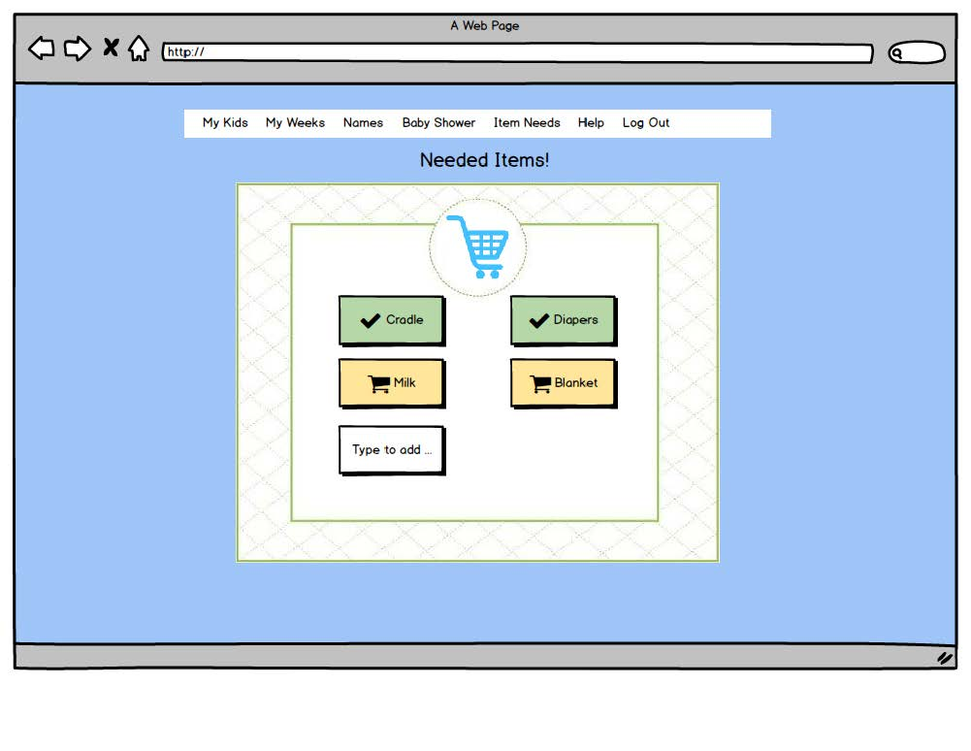

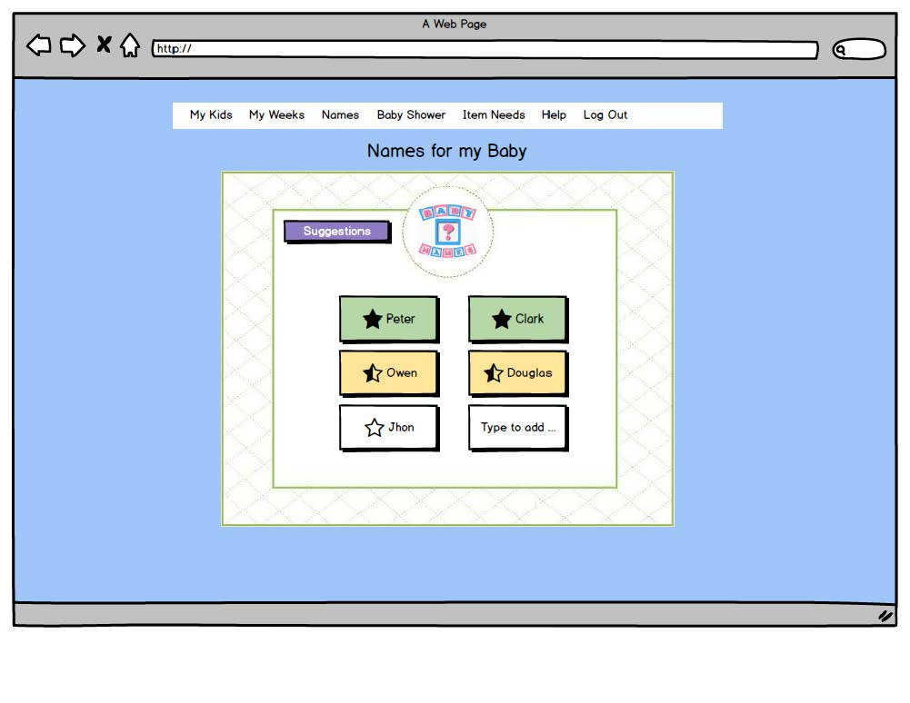

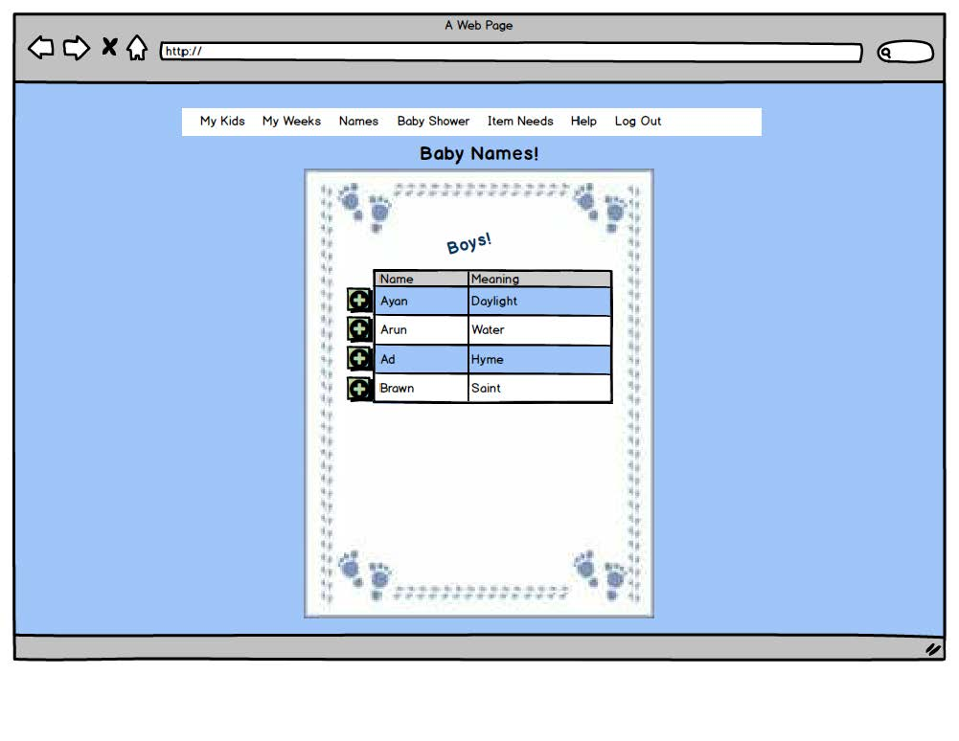

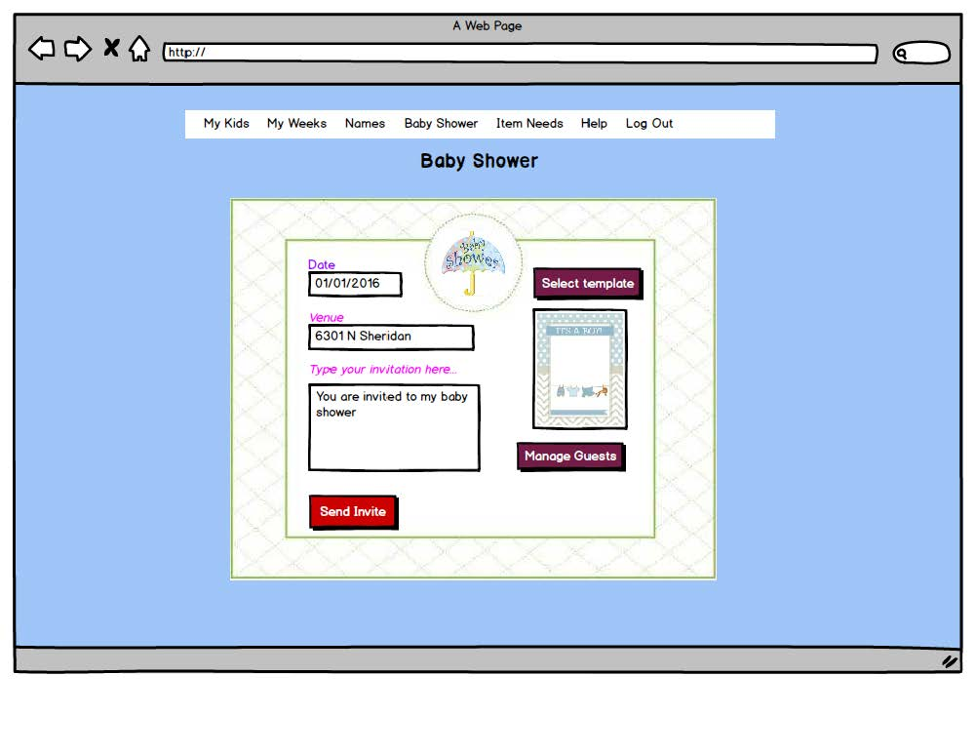

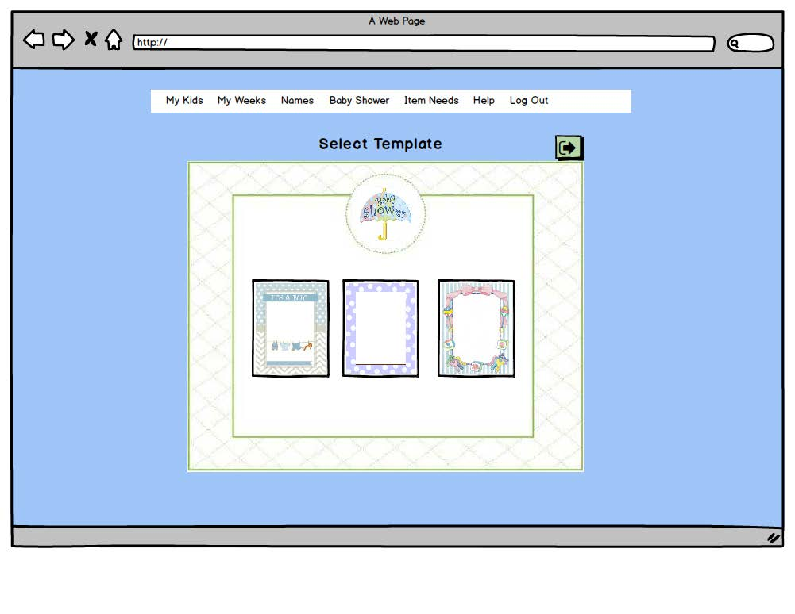

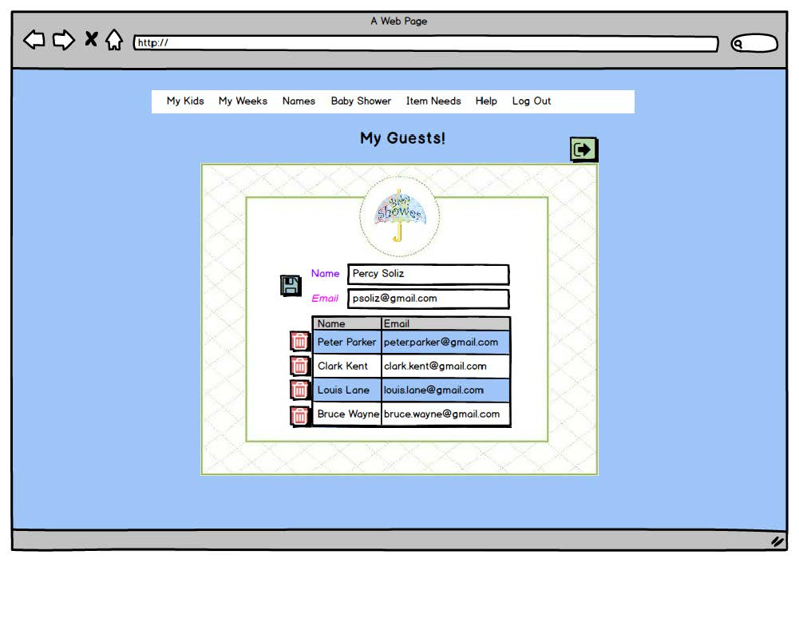

# **Reports**

Currently reports have not been part of the requirement from the user so there’re no reports created so far.

# **Design Specification**

## **Narrative Overview**

### **Interface/Dialogue Name:**

This application will require a front-end web component for the patient, and back-end web application for the administrative staff. Both patients and the administrative staff would use LDAP authentication to access the application. The patient will be able to input information directly into the application and the administrative staff will be able to pull information from the patient’s inputs directly to give to the doctors.

### **User Characteristics:**

The users of this system will be the staff at Healing Hands and the patients. Patients who will be using it will those who do not want to come in weekly for counseling services that they can receive via the online interface or an app. The staff at Healing Hands will be using the system to input patient information as well as be the site administrator.

### **Task Characteristics:**

Patient Side: The patient will log into their account and be able to access their individual records. They will be able to view their previous pregnancy records as well as add new records. The patient will be able to see their individual records week by week. Each week will have a nutritional needs section, a physical developments section, a symptoms page, and a photo gallery page. Each account will have the ability to access a database of baby names, the ability to plan a baby shower and make a list of items needed.

Administrative Side: When a patient registers for an account, the administrative staff will issue them a username from the email that they submit and an automatic generic password will be generated (the patient will be able to change this upon their first login). The administrative team will be able to monitor each patient’s records by week. They will be able to enter information from patient appointments under any given week and print reports about patient symptoms before an office visit.

### **System Characteristics:**

This application runs on a client-server, and can be accessed by users when they attempt to visit the designated web page. While the user is accessing the site, the browser interprets and displays the pages. The application interacts via page scripts that store and retrieve data. The application is divided into a three-tiered structure: presentation, application and storage. The presentation tier is the web browser, the application tier uses web content technology which supports the database that is the storage tier.

### **Environment:**

This application will be housed on a dedicated web serve physically secured in Healing Hands data center. There will be a fallback server housed at a remote location to ensure limited or no service interruption. Users can access the application from any web-browsing device.

## **Interface and Dialogue Designs**

### **Forms/Reports Design:**

The forms and reports of the application are designed to provide a comprehensive and user-friendly experience for patients and the administrative staff alike. Sample forms and reports are included in this document.

### **Dialogue Design:**

The dialogue design demonstrates the steps involved with the patient’s interactions with the system. The dialogue diagram is included within this document.

## **Testing and Usability Assessment**

### **Testing Objective:**

The objective of testing is to determine the usability of the system. We are testing from the patient perspective as well as the administrative staff’s perspective. Documenting both the program and system tests and the results of these tests are essential to ensure the application functions optimally once launched.

### **Testing Procedures:**

The testing procedure for this application follows the standard testing process of confirming that all system requirements have been met, and is planned. The following are important scenarios to test for this application:

1. The administrative staff’s login email generation
2. The patient’s ability to login and change their password
3. The patient’s ability to create a new record for each pregnancy
4. The patient’s ability to see multiple weeks at a time
5. The patient’s ability to check their nutritional plan each week
6. The patient’s ability to enter symptoms into their personal page
7. The patient’s ability to access the database of baby names
8. The patient’s ability to use the baby shower planning functions on the site
9. The patient’s ability to add items to their items needed list
10. The administrative staff’s ability to monitor each patient’s records weekly

The administrative staff’s ability to check on each patient’s symptoms entered

## **Dialogue Diagram**

Dialogue design is a method of outlining and modeling human-computer interactions using box and line diagrams. In the diagram below, the system is outlined using this method by demonstrating the screens that patients and administrative staff would encounter while navigating throughout the system.

### **Diagram**

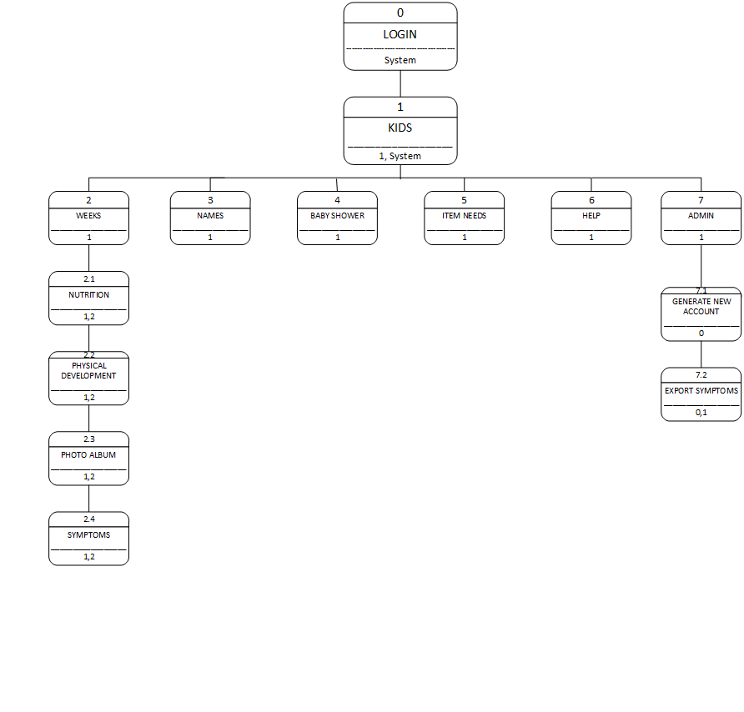

## **Distributed System Design**

### **Description of Site:**

1. Geographical Information: the primary web server will be stored in a secure data resource center, with a backup service stored close by.
2. Physical Location: the primary web server will be housed on one of the server racks that that hospital is currently using. The backup server will also be housed on an existing hospital server.
3. Infrastructure Information: both the primary and backup servers are housed in a secure data room, which requires a key card to gain access. Only people with special authorization will be able access this room. As needed, repair and non-approved personnel will be granted access but only with approved personnel present.
4. Personnel Characteristics: both the primary and back up servers will be handled by trained personnel only who have experience in dealing with web servers and related functions. Personnel will either already be employed by the hospital or will be hired on a contractual basis.